ASSIGNMENT 4

TEAM ID:PNT2022TMID47645

/*
HC-SR04 Ultrasonic Sensor Example.

Turn the LED on when an object is within 100cm range.

*/
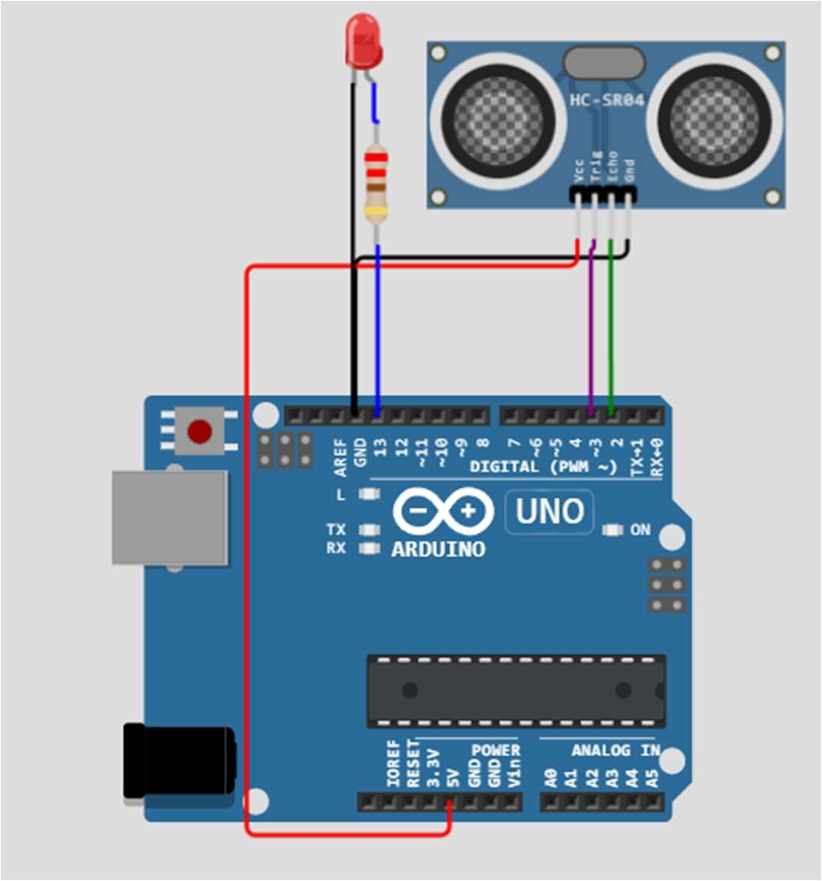

#define ECHO_PIN 2
#define TRIG_PIN 3

void setup() { Serial.begin(115200); pinMode(LED_BUILTIN, OUTPUT); pinMode(TRIG_PIN, OUTPUT); pinMode(ECHO_PIN, INPUT);
}

float readDistanceCM() { digitalWrite(TRIG_PIN, LOW); delayMicroseconds(2); digitalWrite(TRIG_PIN, HIGH); delayMicroseconds(10); digitalWrite(TRIG_PIN, LOW);
int duration = pulseIn(ECHO_PIN, HIGH); return duration * 0.034 / 2;
}

void loop() {
float distance = readDistanceCM();

bool isNearby = distance < 100; digitalWrite(LED_BUILTIN, isNearby);

Serial.print("Measured distance: ");
Serial.println(readDistanceCM());

delay(100);
}

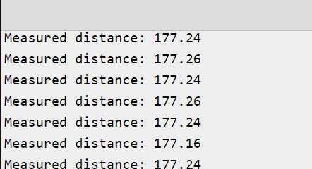

Link: https://wokwi.com/projects/347042511360885330

